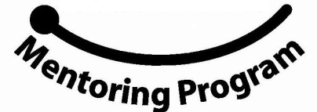
Women and Math Mentoring Program
WAM

The Women and Math Mentoring Program (WAM) has begun recruiting for its 19th year. The program seeks women with careers in mathematics, science, technology, or other math-related fields for the 2012-2013 Math Mentoring Program.

The program serves 8th grade girls from public middle schools in Durham County. The program aims to encourage girls who have an interest in mathematics to “stay on the math path.” Small groups of 2 to 3 eighth-grade girls are teamed up with local female professionals who work in mathematics-related fields. Through monthly interactions, the girls learn about their mentor’s profession, as well as many other math-related careers.

MENTOR ORIENTATION for 2012-2013 will be held on Saturday, November 10th, 2012.

The event will be in the morning from 9am until 11:30am and is held at the Mary Townes Science Complex at NC Central University in Durham. During the orientation, mentors will be organized into small mentor groups, choose the students they wish to work with, and receive training and materials. The mentor groups, led by experienced mentors, provide ongoing support throughout the Program and a great opportunity for networking.

All women interested in being a mentor for the 2012-13 school year should visit our website or email us for an application:

Dr Laura Smith – lbsmith1965@nc.rr.com

www.WomenandMathMentoring.org

